STUDENT DETAILS
Student Name: Joan Wairimu Muchiri
Admission Number: BSCCS/2024/53575
Course/Class: Computer Science
Unit Code: BIT3208
Unit Name: Advanced Web Design and Development
Lecturer Name: Nyoro Michael
Semester/Academic Year: 3.2
Contents
Week 6: Database Integration and CRUD Operations 1
Title 1
Required Evidence 1
Student Reflection 1
Week 7: User Authentication and Session Management 3
Titl 3
Required Evidence 3
Student Reflection 3
Week 8: Responsive Web Design and Mobile-First Development 5
Title 5
Required Evidence 5
Student Reflection 5

Week 6: Database Integration and CRUD Operations

Title
Full CRUD Implementation with Search Functionality

Required Evidence

Fig 1: suppliers table structure

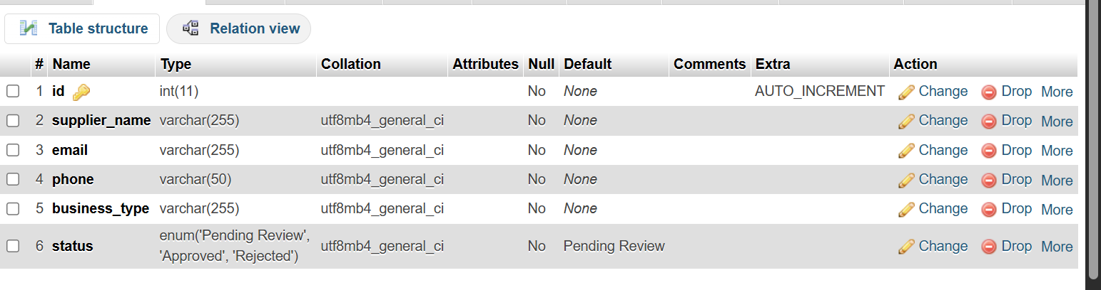
Fig 2: Add Supplier form
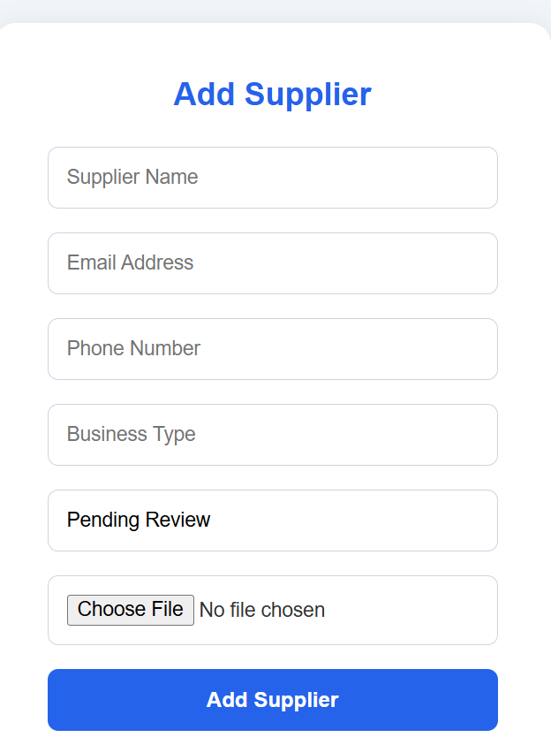
Fig 3: View Suppliers page.
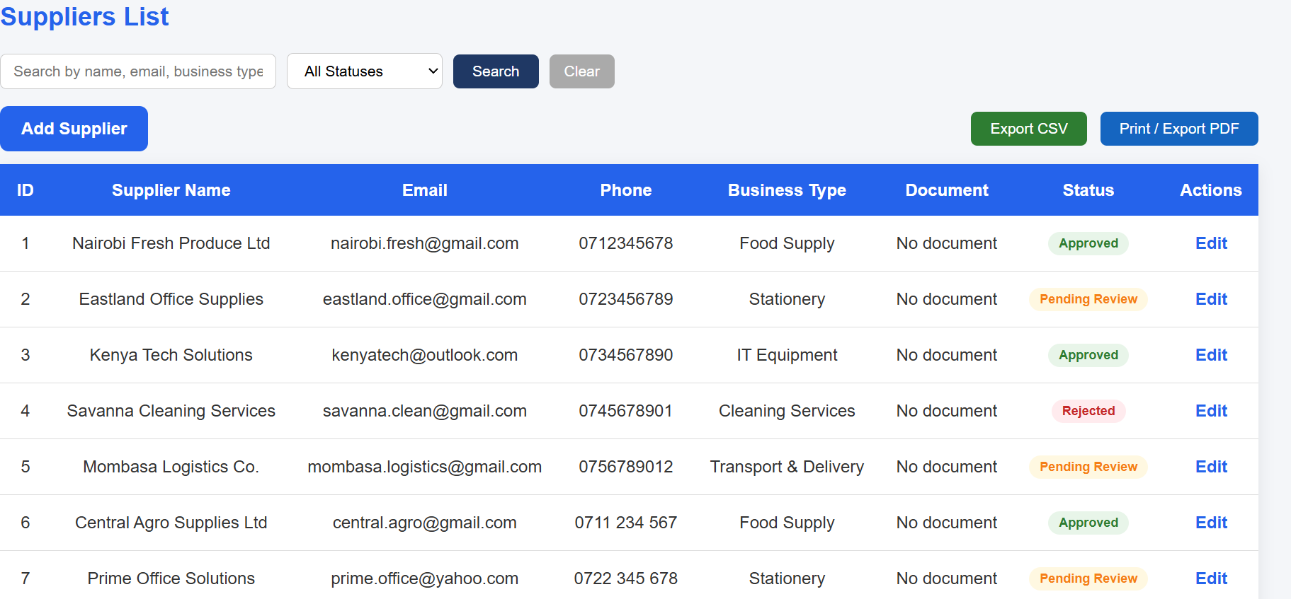
Fig 4: Search and filter functionality active on the View Suppliers page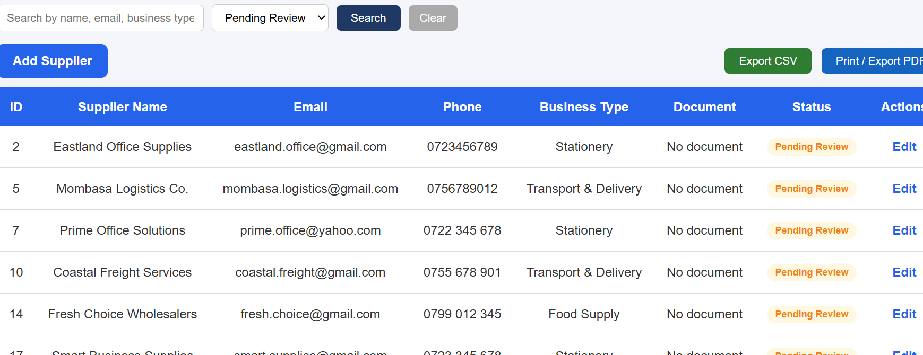
Fig 5: Edit supplier form
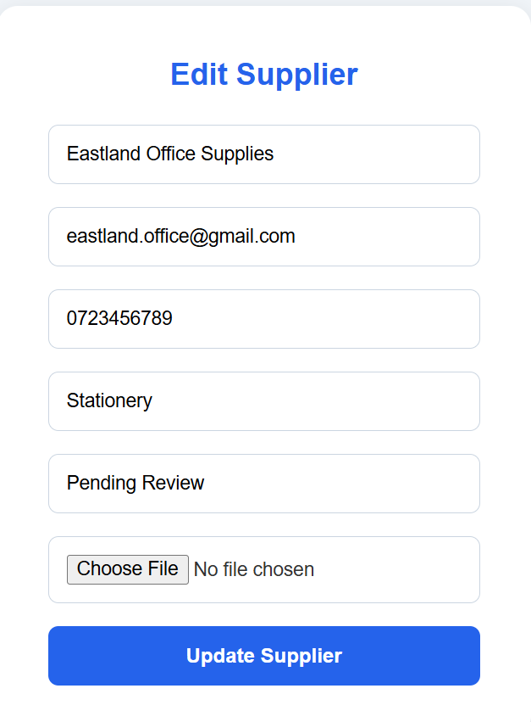

Student Reflection
This week focused on implementing full CRUD functionality for the Supplier Verification System. I developed features to add, view, edit, and delete supplier records stored in the MySQL database. I also implemented search and filter functionality using SQL WHERE and LIKE clauses to improve usability. A key challenge was pre-populating the edit form with existing data before updating records. Overall, these features improved both the functionality and user experience of the system.

Week 7: User Authentication and Session Management

Title
Secure Login, Role-Based Access, Remember Me and Session Control

Required Evidence
Fig 1: login.php file open in VS Code showing the password_verify() function

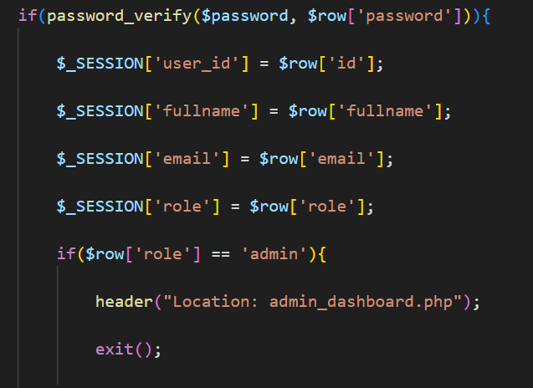
Fig 2: Session verification logic restricting access to authenticated users only.
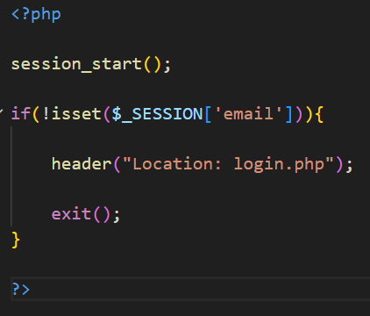

Fig 3: Users table displaying different user roles including Admin, Manager, and Procurement Officer and hashed passwords
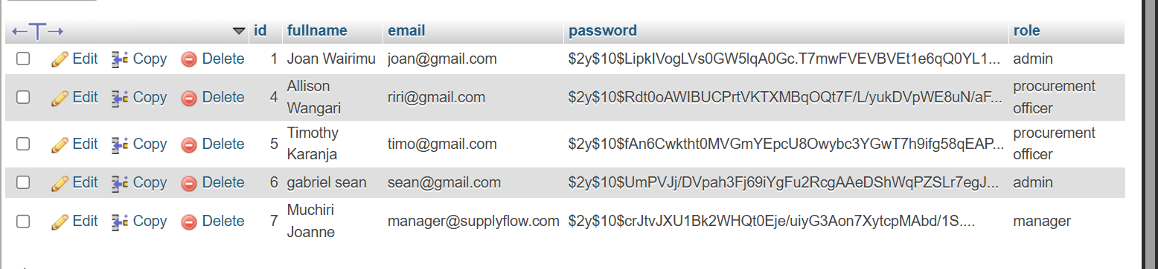
Fig 4: All three role-based dashboards with a logout functionality
4.1: Admin dashboard
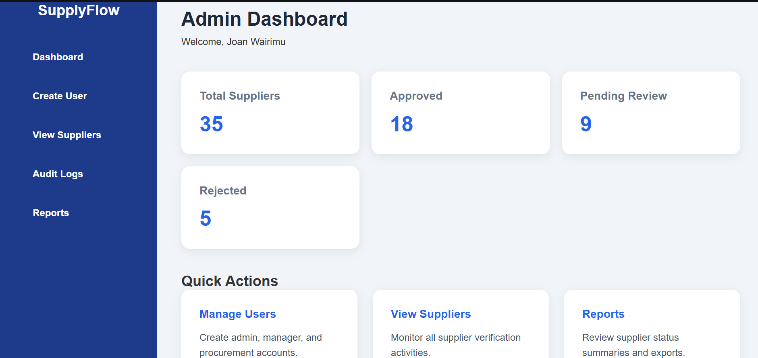
4.2 Manager dashboard
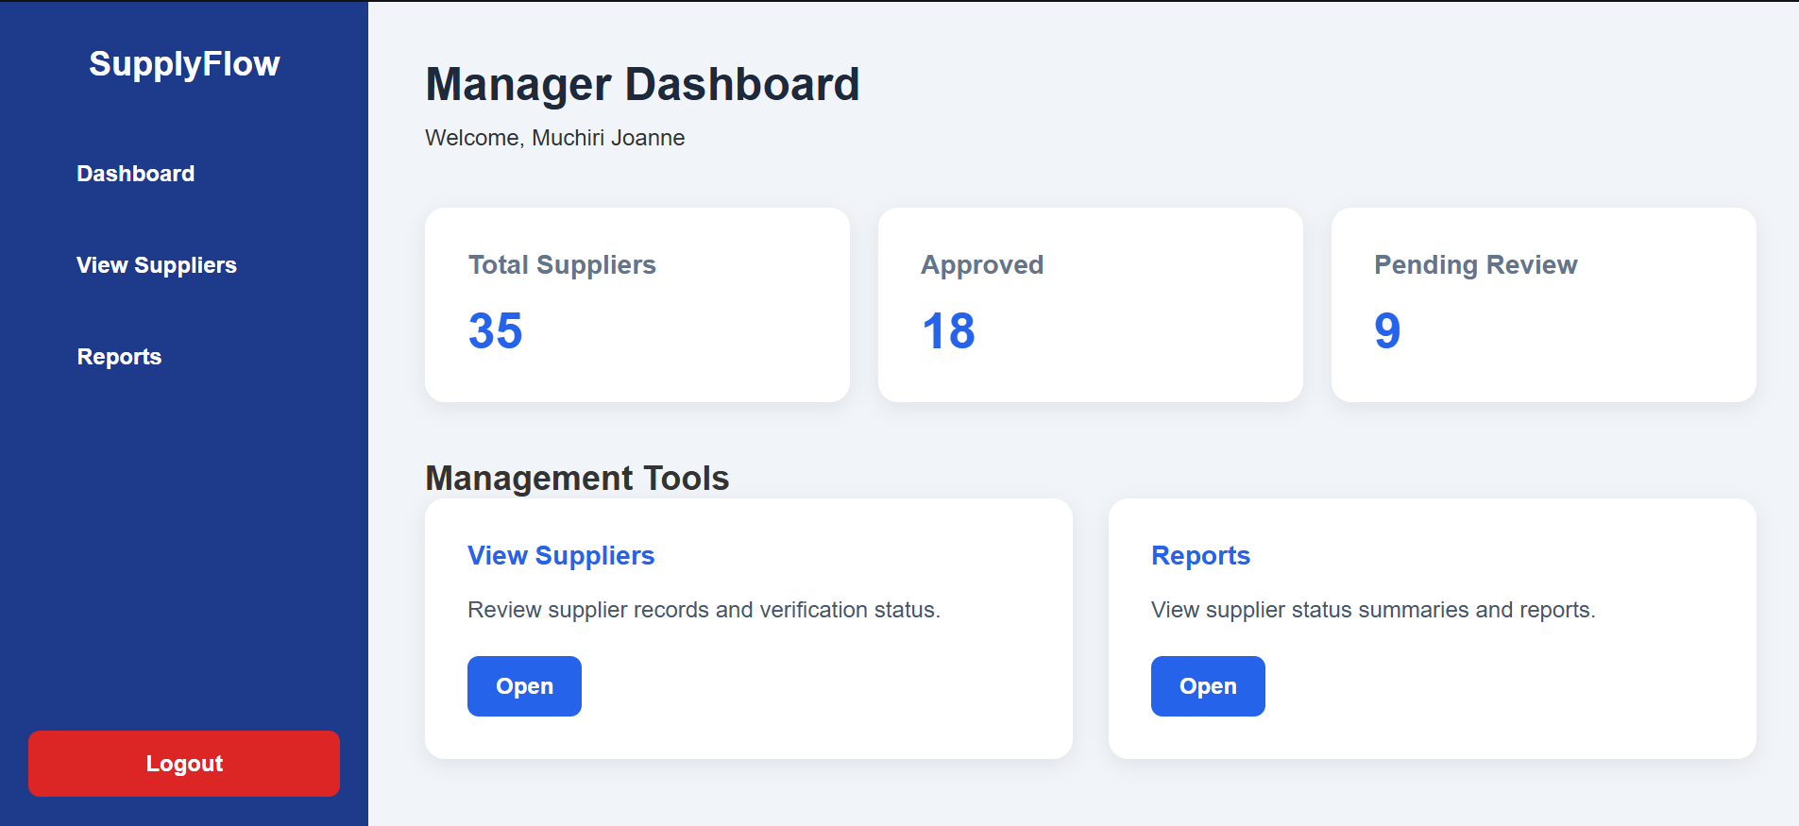
4.3 Procurement officer dashboard
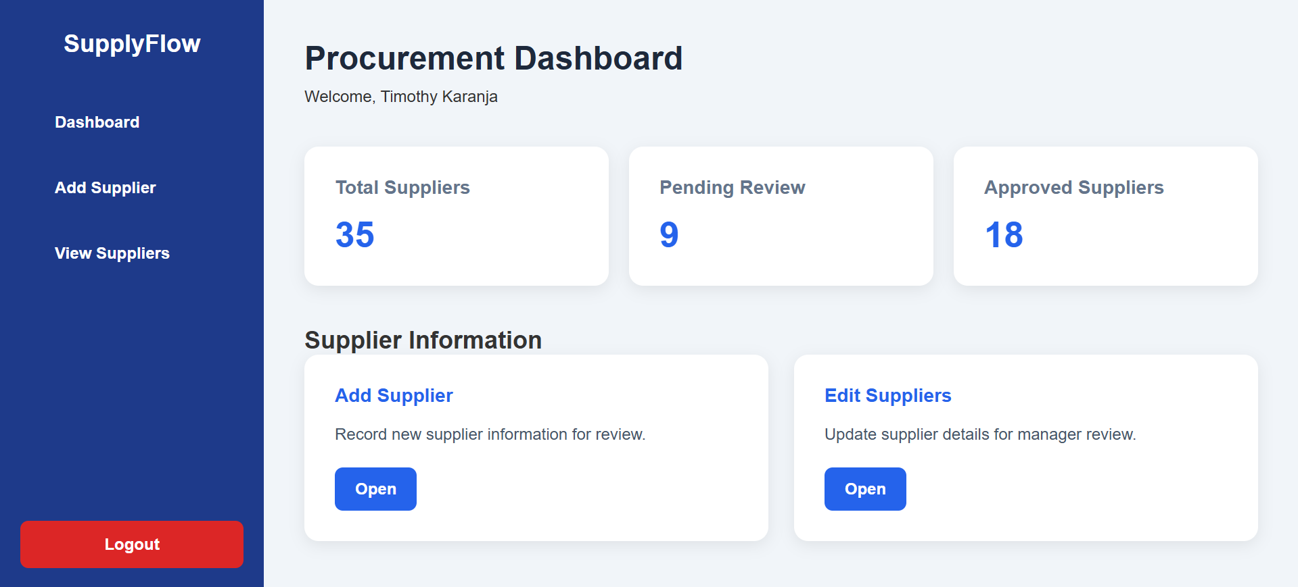
Fig 5: Login page showing the Remember Me checkbox
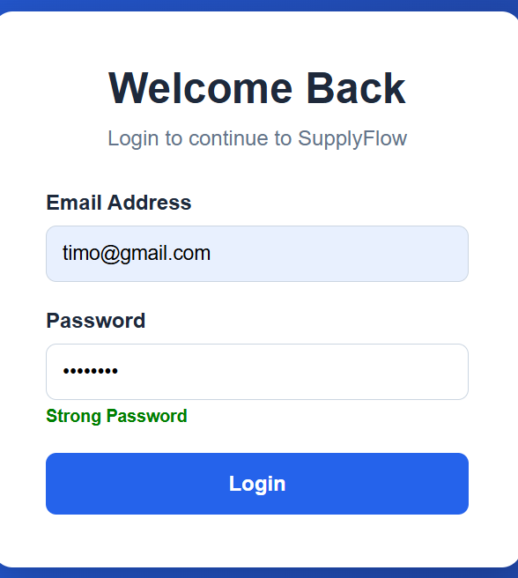

Student Reflection
This week focused on implementing a secure user authentication system with role-based access for Admin, Manager, and Procurement Officer. I used PHP sessions to manage user logins, password_hash() and password_verify() to secure passwords, and cookies for the Remember Me feature. A challenge was ensuring users were redirected to the correct dashboard based on their role while preventing unauthorized page access.

Week 8: Responsive Web Design and Mobile-First Development

Title
CSS Media Queries, Flexbox, CSS Grid and Mobile-First Layout Design

Required Evidence
- Fig 1: style.css file open in VS Code showing the CSS media query breakpoints implemented in the project
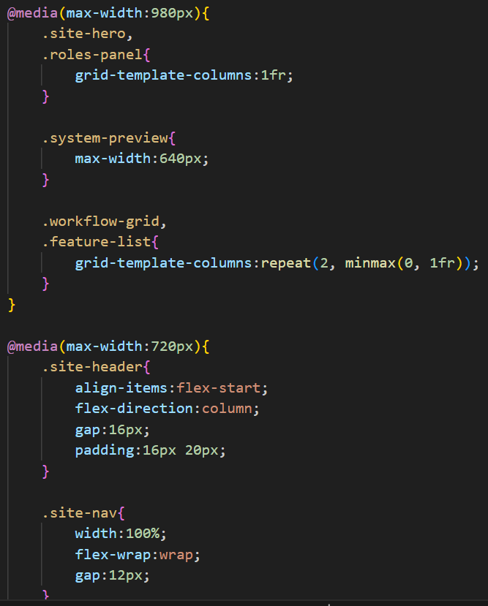
Fig 2: SupplyFlow homepage displayed at full desktop width in the browser 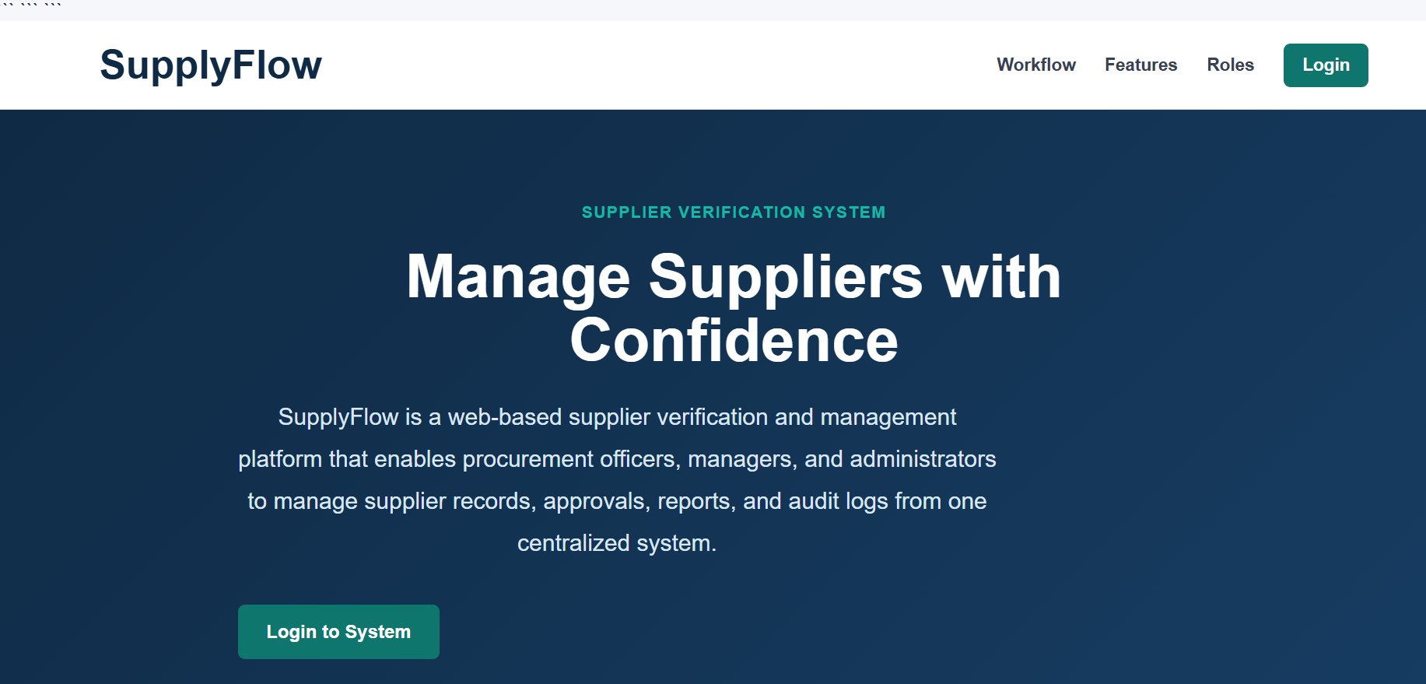
Fig 3: SupplyFlow homepage displayed in browser developer tools responsive mode at 980px tablet width
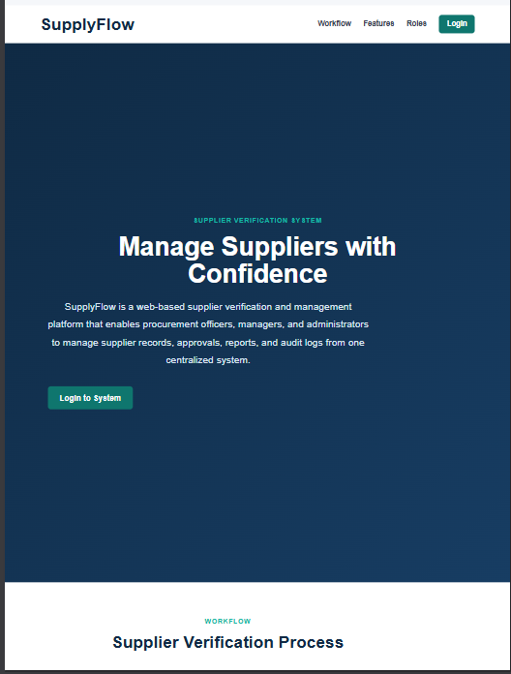
- Fig 4: SupplyFlow homepage displayed in browser developer tools responsive mode at 720px mobile width size
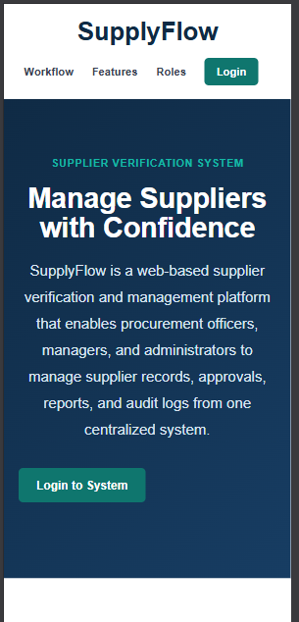

Student Reflection
This week focused on making the SupplyFlow system responsive across desktop, tablet, and mobile devices. I implemented CSS media queries, Flexbox, and CSS Grid to adapt layouts to different screen sizes. A challenge was redesigning the dashboard sidebar for mobile devices, which I resolved by converting it into a horizontal navigation bar. The responsive design ensures the system remains functional and easy to use on all devices.

Extra activity
Audit logs
Added a system activity tracker that automatically records every significant action performed my authenticated users, including supplier approval,rejections,rejections and deletions. This allows the admin to track who did what and when which is essential for accountability in a procurement system.
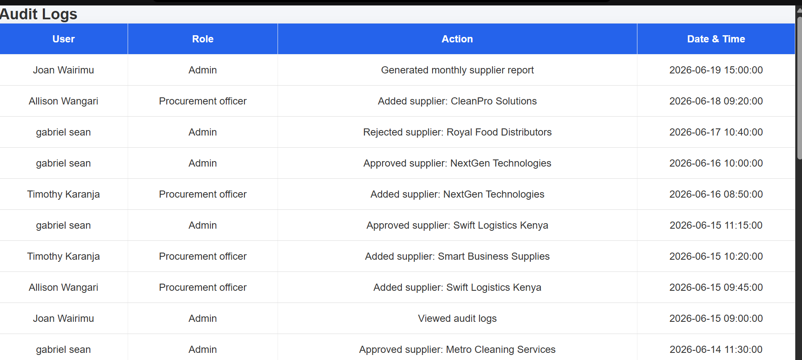
Reports

A summary dashboard that pulls live statistics from the suppliers table and displays total suppliers, approved count, pending review count and rejected count. This gives the admin and manager users a quick overview of the current verification status across all suppliers without manually counting the records.
A data export feature was added to the Reports page allowing Admin users to download the current supplier verification summary as a CSV file.
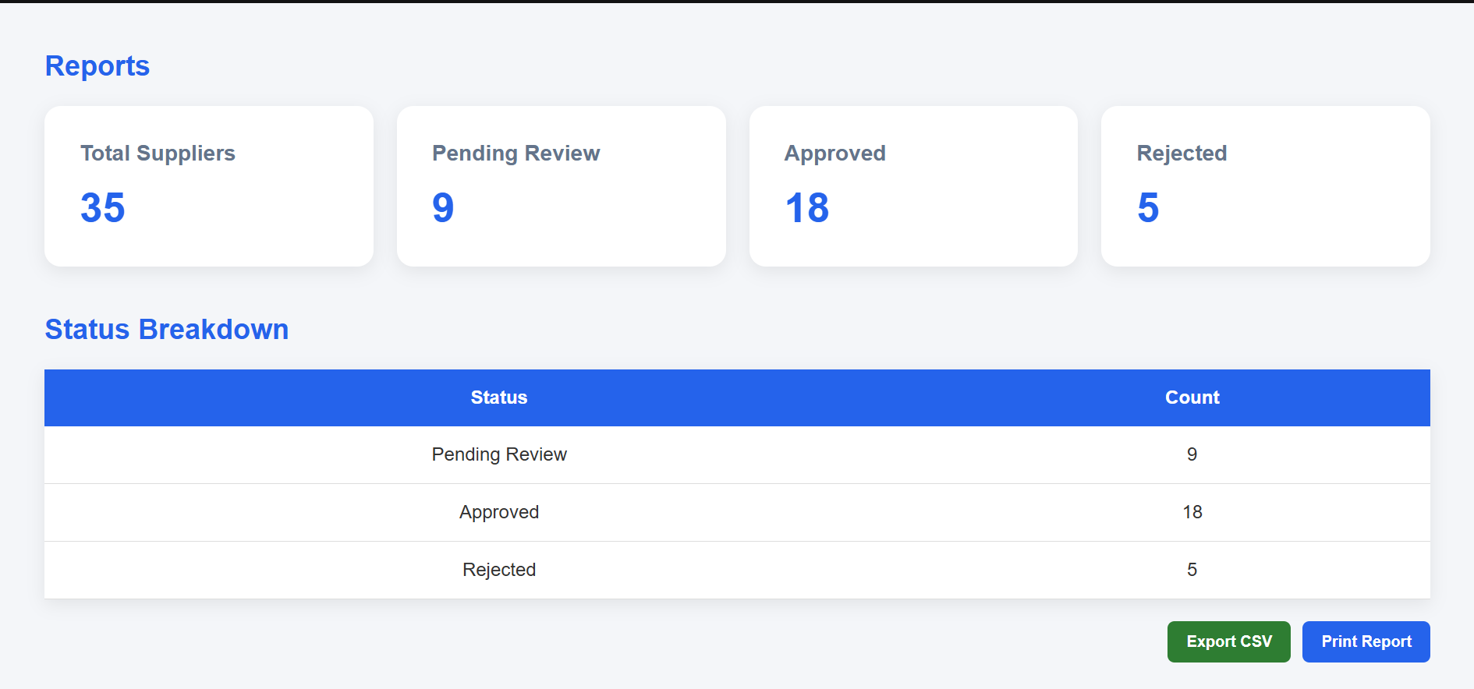

System Evolution:
Weeks 1 to 5 focused on building the core system with two roles; Admin and Procurement Officer, covering environment setup, UI design, JavaScript validation, PHP authentication and basic CRUD operations.
Weeks 6 to 8 expanded the system significantly. A third role, Manager, was added to create a realistic three-tier procurement workflow where Procurement Officers submit suppliers for review, Managers approve or reject them, and Admins monitor everything through audit logs and reports. Additional features added include search and filter, CSV export, file upload for supplier documents, Remember Me login, and full responsive design across all screen sizes.

